1. Draw a labeled diagram of a desktop PC, clearly marking the motherboard, CPU, RAM, GPU, and both HDD and SSD storage components.

Cabinet Components

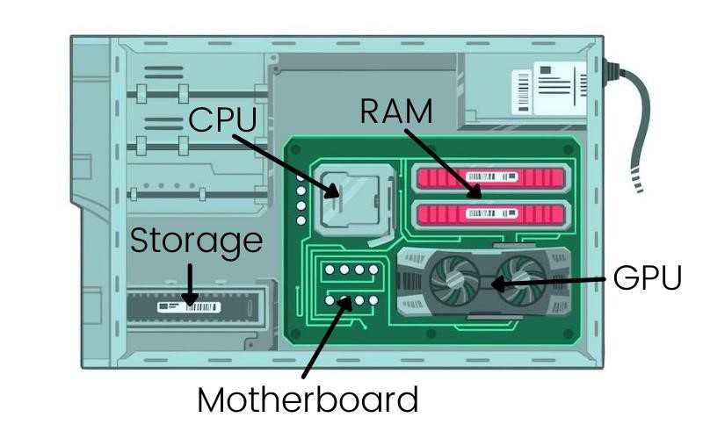

2. Create a comparison table showing the main differences between HDD and SSD storage in terms of speed, durability, and typical use cases.

Different Between HDD and SSD

HDD (Hard Disk Drive)-
- Slower data access and file transfer speeds (typically 80–160 MB/s
- Generally uses more power
- Longer operating system startup times
- Generates more heat
- Bulk storage, backups, media archives, surveillance recordings

SSD (Solid State Drive)
- Uses flash memory with no moving parts
- Much faster data access and transfer speeds (typically 500 MB/s to several GB/s, depending on type)
- More energy-efficient
- Generates less heat
- Operating systems, gaming, professional software, laptops, and performance focused computing

3. Write a short explanation (2-3 sentences each) describing the role of the CPU, RAM, and GPU in running a game like PUBG or Free Fire on a PC.

CPU (Central Processing Unit)
- The CPU acts as the game's main processor, handling tasks such as player inputs, game logic, physics calculations, and AI behavior. In games like PUBG or Free Fire, the CPU ensures that all game events are processed smoothly and in the correct order.

RAM (Random Access Memory)
- RAM temporarily stores the game data and assets that are currently being used, allowing the system to access them quickly. Having enough RAM helps reduce loading times and prevents stuttering when the game needs to access textures, maps, and other resources.

GPU (Graphics Processing Unit)
- The GPU is responsible for rendering the game's graphics, including characters, environments, lighting, and visual effects. A more powerful GPU can produce higher frame rates and better visual quality, resulting in a smoother and more immersive gaming experience
4. Imagine you want to upgrade your PC to run the latest version of FIFA smoothly. List which hardware components you would consider upgrading and explain why for each.

Priority Order for Upgrades
- GPU – Most important for gaming performance.
- RAM – Ensure you have enough memory (preferably 16 GB or more).
- SSD – Improves loading and system responsiveness.
- CPU – Upgrade if the current processor is limiting performance.
- PSU and Cooling – Upgrade as needed to support new hardware.
This approach provides the best balance between performance improvements and upgrade cost for modern FIFA games.

